## **INDEX**

## **1. Introduction**

## **2. Objective**

## **3. Project overview and summary**

## **Purpose of Project**

## **3.2 Scope of Project**

## **3.2.1 General Requirements**

## **3.2.2 Interface Enhancements**

## **3.3 Overview of Project**

## **3.3.1 Features**

## **4. System Specification**

## **4.1 Software Requirements**

## **4.2 Hardware Requirements**

## **5. System Analysis**

## **5.1Existing System**

## **5.2Proposed System**

## **6. Project Modules**

## **6.1Buying ticket**

## **6.2 Administrative Staff**

## **6.3My Modules**

## **7. Coding and Screen Shots**

## **8. Conclusion**

## **9. Bibliography**

1. **INTRODUCTION**

The main aim of this project movie ticket booking system is a best way of ticket booking for Cinema Halls. For tickets and Enquiries about availability of the tickets. This movie ticket Booking System is an Internet based application that can be accesses throughout the Net and can be accessed by anyone who has a net connection. This application will automate the reservation of tickets and Enquiries about availability of the tickets. This application includes email confirmation for the tickets. This is one of the important features of our system.

By examining the existing system on the internet, we found that there is no such function available at this moment, so we try to include it in our system. To protect the benefit of the cinema, we will not give the money back to the customer, instead the customer has to visit cinema hall for further process. So, the customer can get the money from the cinema hall. Hence both the customer and the cinema can sort out further matter.

**Functional components of the project:**

Following is a list of functionalities of the system. More functionality that you findappropriate can be added to this list. And, in places where the description of functionality is not adequate, you can make appropriate assumptions and proceed. The Cinema hall has a web site and any user of internet can access this. The cinema hall is a multiplex which has 2 or more screens. Each screen has 3 different types of seats/classes via Platinum, Gold & Silver depending on the rate of the class/seat. Only 100% of the seats are available for online reservation:

1. A person should be able to:

•Choose city where he/she want to see the Movie.

•Choose the film which he/she wish to book tickets.

•Query the films on show for one weeks (Only one week’s advance reservationist available) should be there.

•Able to choose the seats which are available for a certain class.

•Can select seats from different classes as well for same show and screen also.

•Give details about the credit card or debit card through which he is doing payment.

•Able collect tickets at the counter presenting the unique id send to him/her through email.

2. A mail should be send to the concerned person about the confirmation of the ticket to the specified email address.

3.The system should automatically show the fare for the corresponding shows andamount of money needs to be pay for selected seats.

**2. OBJECTIVE**

The main objective of the movie ticket booking system is to manage the details of seats, booking, customer, payment, shows. It manages all the information about seats, movie show. The project is totally built at administrative end thus only the administrator is guaranteed the access. The purpose of the project is to build an application program to reduce the manual work for managing seats, booking, movie, and customer. It tracks all the details about the customer, Payment, Shows.

Further cinema hall owner has to hire large number of staff at the counter for selling tickets. Enquiries about movie, etc. Hence this system is much tedious and not much user friendly as per the need of current scenario.

**3. Project Overview and Summary**

**3.1 Purpose of Project:**

The main purpose of our ticket booking system is to provid­e another way for the customer to buy cinema ticket. It is an automatic system. After inserting the data to database, staff needs not to do with the order receive through the system. In fact, there is similar system on the internet, but there is no refund method found in the existing system. The goals of our system are:

1. To provide a anytime anyplace service for the customer

2. To promote the film on the internet

3. To increase the profit

4. To obtain statistic information from the booking record

**3.2 Scope of Project:**

**3.3.1 General Requirements (functional):**

1. The web page (e.g. the time table page) will be generated automatically according to the data in database.

2. A way in which the cinema hall admin (staff) can login to the system to perform different operation.

3. A way in which the customer can modify its own data (booked seats before payment).

4. A way in which the customer can commit order by just clicking the seat (which is shown on the screen) and insert some card data.

5. A way in which the customer can check the ticket record (seat numbers) selected by him/her at the time of payment.

6. A way in which the staff can use the system to add data (e.g. film description) to the database.

7. The system can verify the data before transaction.

8. The system can generate the time table automatically as the time table is set by the staff. (Operating mode for the staff to insert data).

11. The system can generate some statistic information according booking and ticket selling record for the cinema hall per Movie based.

**3.3.2 Interface Enhancements:**

Our web-based system needs about more than 30 interfaces to handle all the functions.

**Staff:** One of the main purpose of our system is to reduce the number of staff in the ticket box. So, most of the job is done by the system automatically. Staff only need to insert new film data and due with the refund part.

**Customer:** To make the system more user-friendly, customer need not to enter lots of data. An order will be commit step by step with guideline (request about 7 steps for an order).

**3.3 Overview of Project:**

Our Ticket Reservation for Cinema Halls is a web-based system. The customers can buy ticket online and cancel the seat at a suitable time (2 days before the show to 1hour before the show) by visiting the cinema hall. To enhance the refund function, all the customers have to present the unique id provided at the time of booking seats online. Staff can use the system to insert and delete data (e.g. film description, time table) which will update the webpage (webpage are dynamic page, changing according to the data in database). Also, staff can check the statistic information from the system.

**3.3.1Features:**

Lists all Times and Theaters

The website lists all of the major theaters, the movies that are showing and the movie times, along with the information of available seats.

**Movie Synopsis**

The online movie ticket site provides a short summary of each movie plot to help you decide if you want to see that movie.

**Trailers**

The online movie ticket site has short movie clips that you can view to get an idea of the plot and genre of the movie.

**Consumer Review**

The movie ticket service offers consumer movie reviews posted and generated by different critics and media.

**Limit Search by Area**

You can limit the movie search by theater location.

**Limit Search by Theater**

You can limit your search by a specific theater.

**Limit Search by Movie**

You can search for a certain movie on the online movie ticket website.

**Limit Search by Date**

You can search for movies according to the date they are showing.

**Message Board/Forum**

The website provides an area for clients to post comments or questions for other consumers to view.

**Upcoming Movie**

The service posts a list of movies that will be in the theaters soon.

**4. SYSTEM SPECIFICATIONS**

**4.1 Software Requirements:-**

* Operating System :Windows XP
* Web Server : Tomcat
* Server side Technology : Servlets, JSP
* Client side Technology : HTML, Javascript
* Database :

**4.2 Hardware Requirements:**

* Pentium 4 processor
* 1 GB RAM
* 40 GB Hard Disk Space

**5. SYSTEM ANALYSIS**

**5.1 Existing System**

In the existing system, the Customer has to visit cinema hall for booking seats. Further they do not even have the information about the Movie which is in the cinema hall, its show time and different rates of the ticket. Even the customer may not be able to get information about different cinema hall available in the city. So, if he wish to see a Movie on a particular day he has to first roam around the city to find out where it is being shown at the specific time.

Further cinema hall owner has to hire large number of staff at the counter for selling tickets. Enquiries about movie, etc. Hence this system is much tedious and not much user friendly as per the need of current scenario.

**5.2 Proposed System**

In order to overcome the existing problem we are making this system as online where every information about any cinema hall, movie, theater and rates can get online which helps the customer to get better facilities at his own computer or laptop. **FUNCTIONALITIES OF THIS SYSTEM** A person should be able to:

* Choose city where he/she want to see the Movie.
* Choose the film which he/she wish to book tickets.
* Query the films on show for one weeks (Only one week advance reservation is available) should be there.
* Able to choose the seats which are available for a certain class.
* Give details about the credit card or debit card through which he is doing payment.
* Able collect tickets at the counter presenting the unique id send to him/her through email.

**6. PROJECT MODULE**

Since the Administrative Staff and the user are the main target group of our software, we will only concern about some important functions for the Administrative Staff and the user. The user can start the buy ticket process after checking the movie detail.

**6.1 Buying ticket**

The buying ticket process is the most important function in our system. We will describe this process in detail.

1. Choose the movie, time and venue
2. Check the status of select venue at certain time.
3. Choosing the seat position.
4. Enter data like ticket type and payment method if the user pay by credit card, credit card number need to be insert too.
5. Validation the data entered by the user.(e.g. credit card number)
6. Ask the user to confirm the transaction.
7. Show the transaction number to the user.

**6.2 Administrative Staff**

The system for the Administrative Staff part is not shown in the main page. Before the Administrative Staff to perform any operation, he/she must login to the system first. Once the Administrative Staff login to the system, the statistic information will be shown. And the Administrative Staff can choose function by clicking the button on left hand side. The functions are:

1. Insert movie data.

2. Delete movie data.

3. Modify movie data.

4. Add new show to current showing movie.

**6.3 My modules:**

* login
* Sign In
* Home
* Movies
* Theatre
* Timings
* Seats
* Total

**7.** **Coding part with screen shots:**

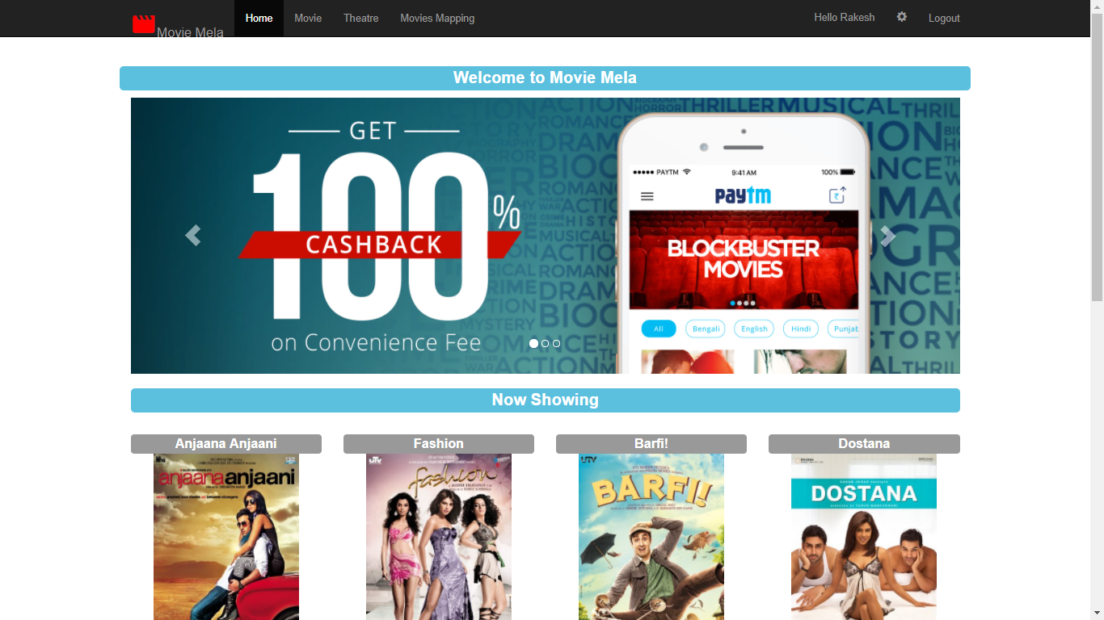

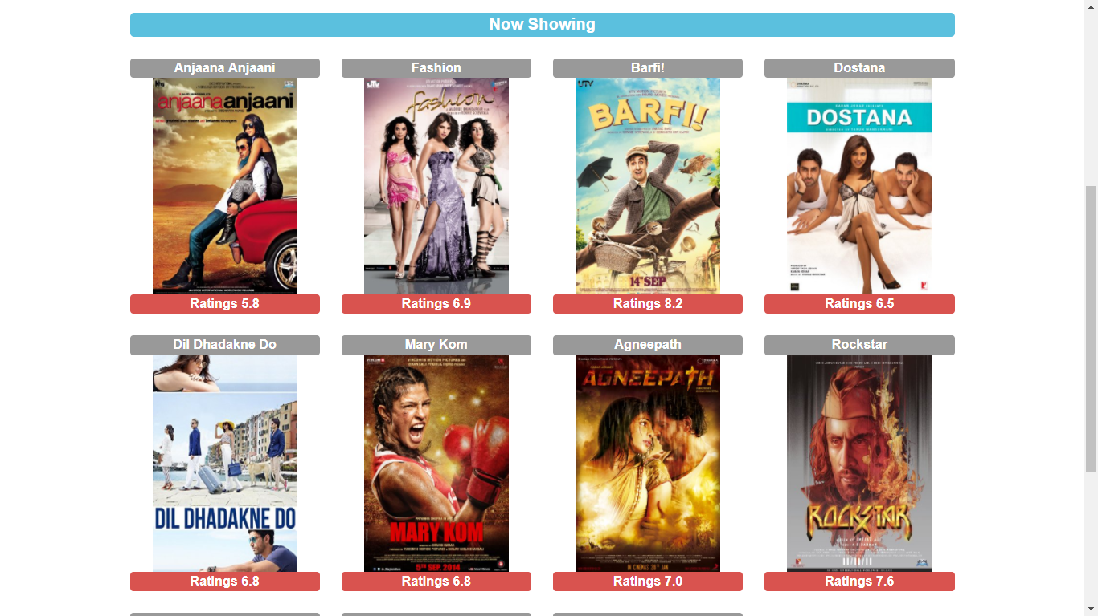

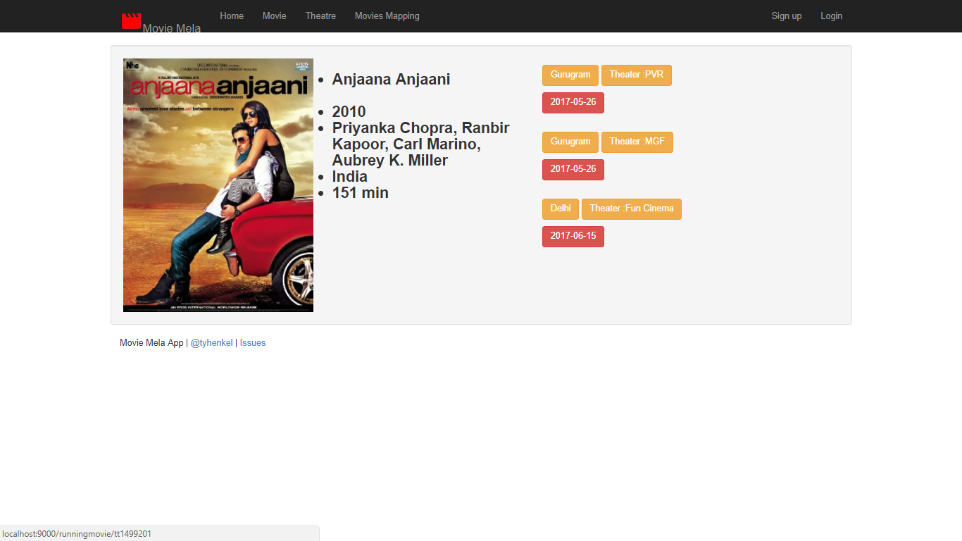

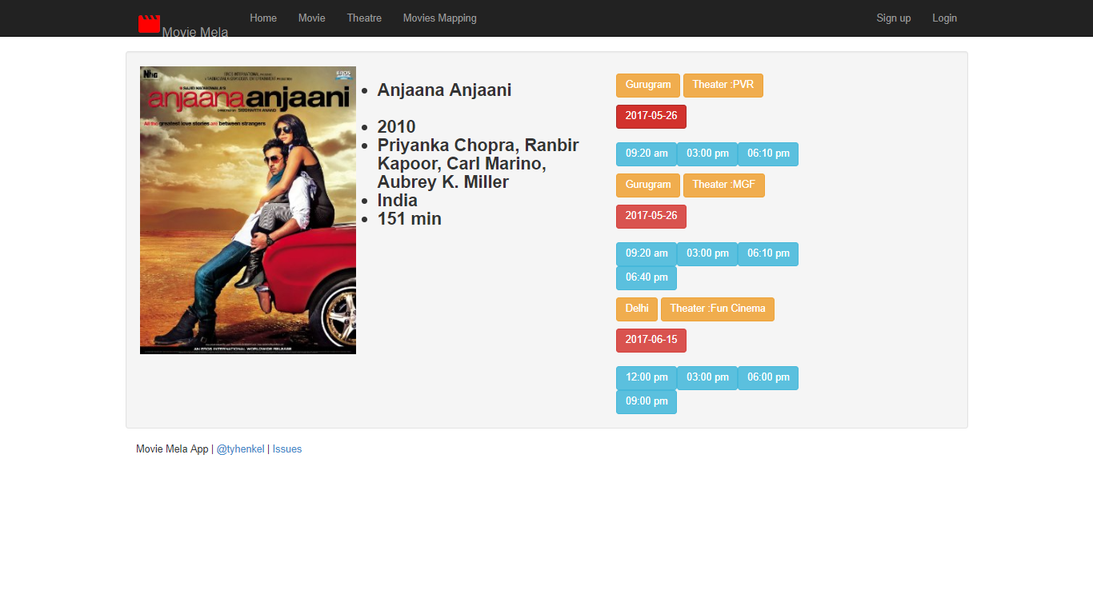

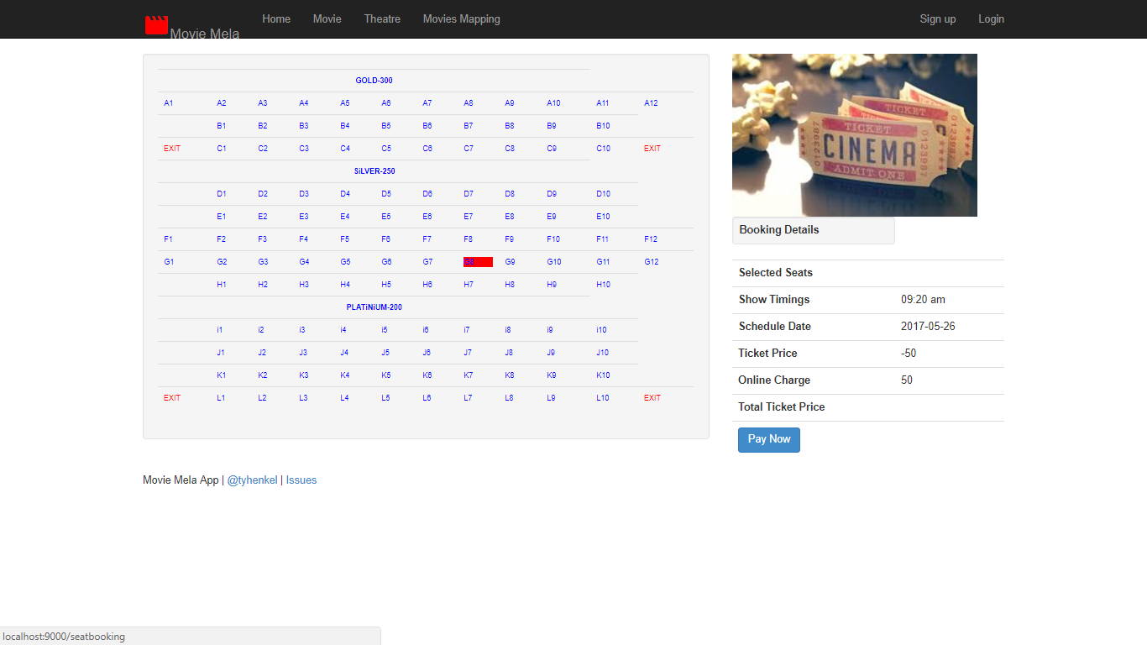

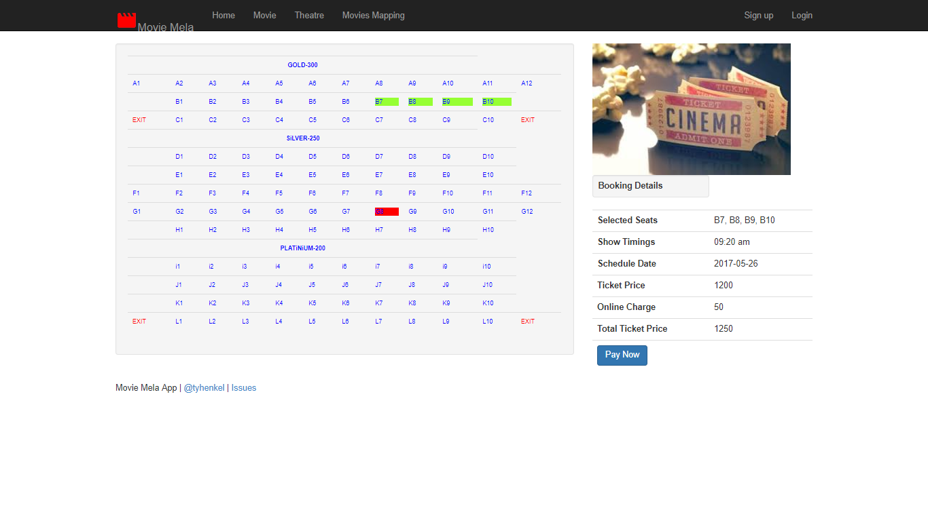

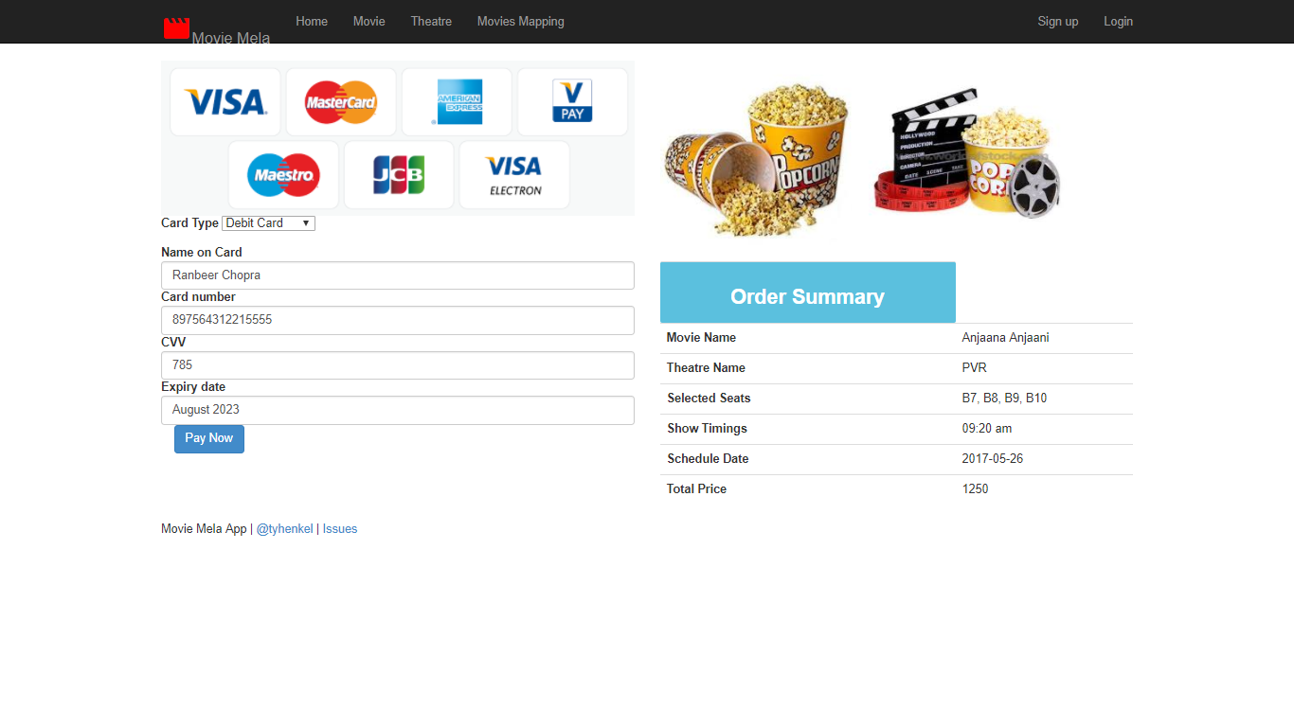

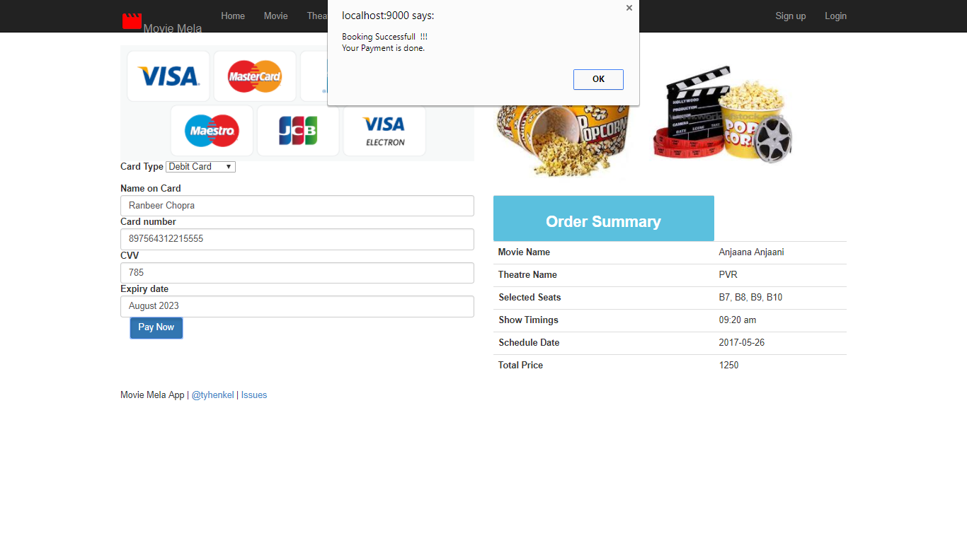

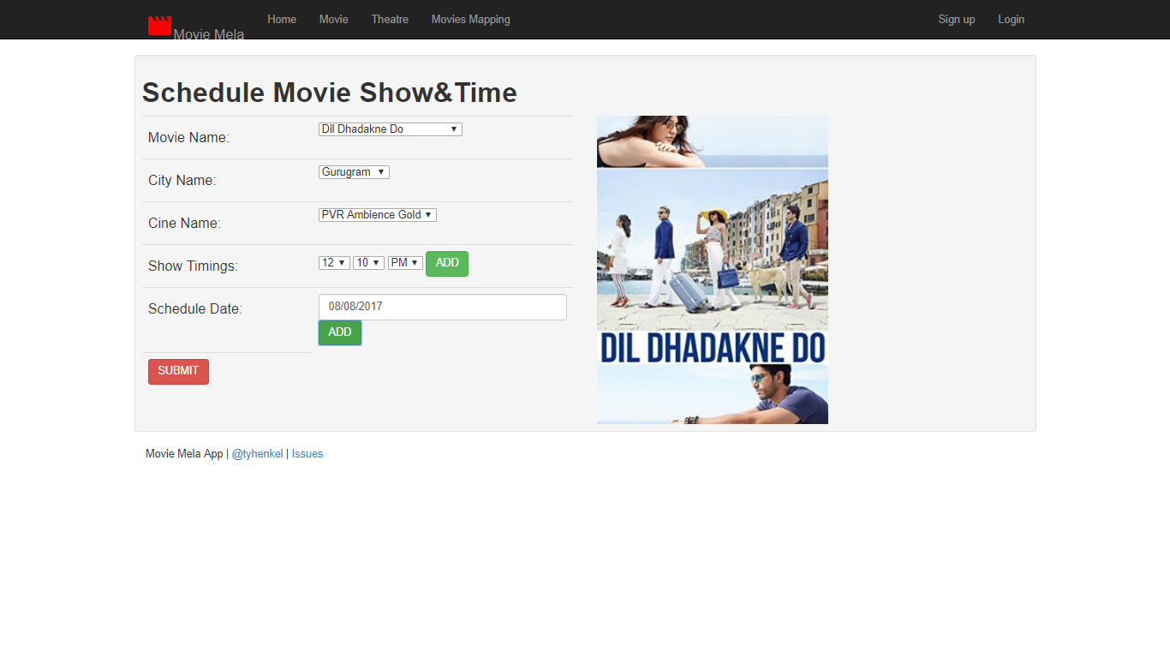

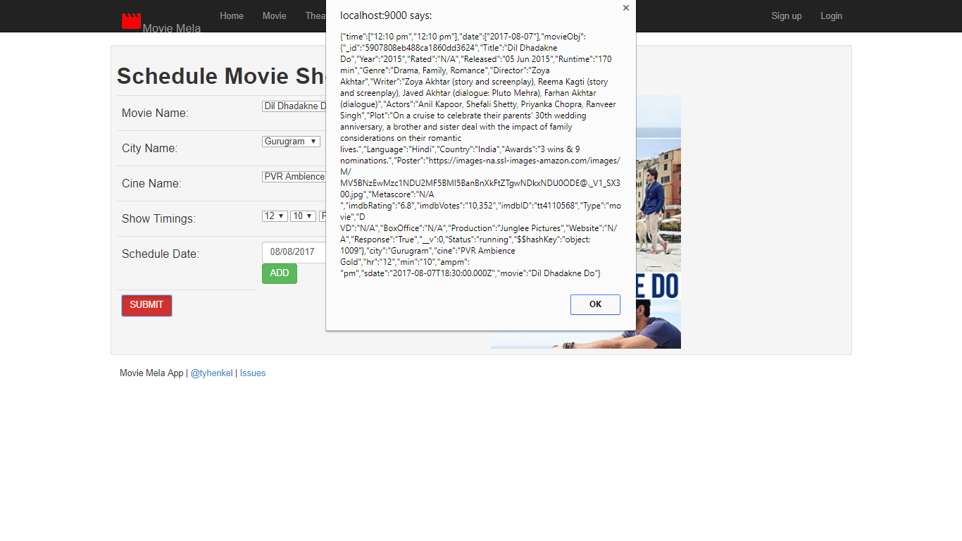

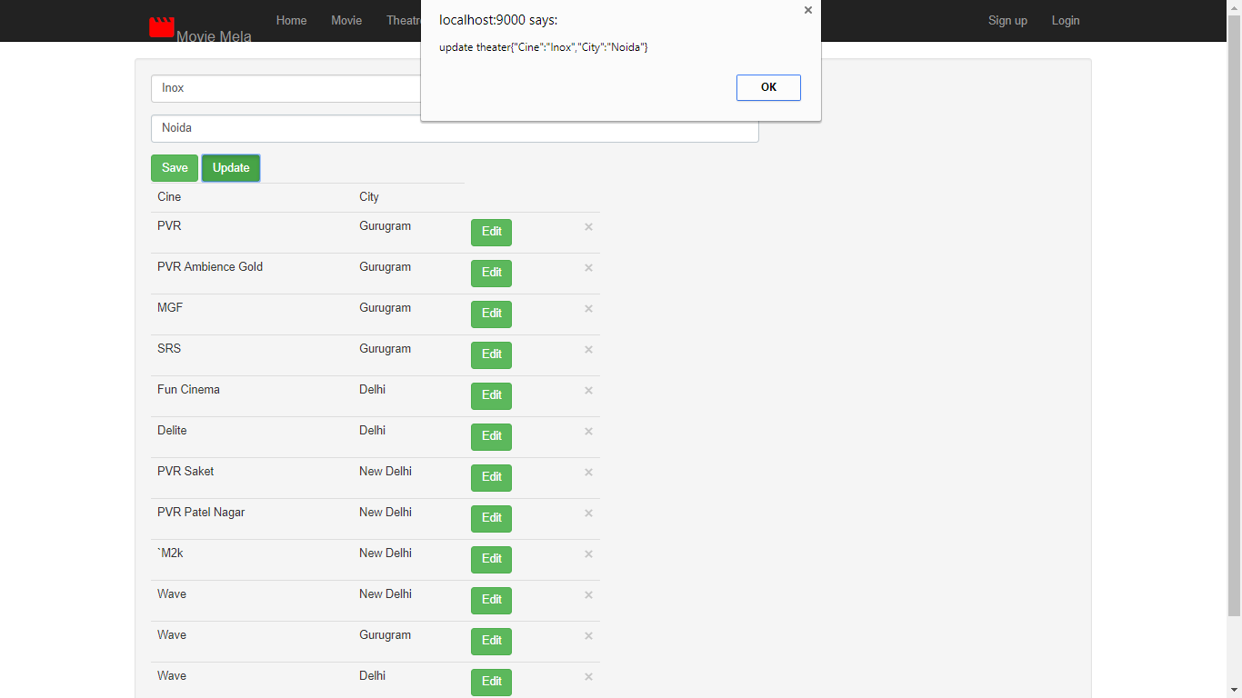

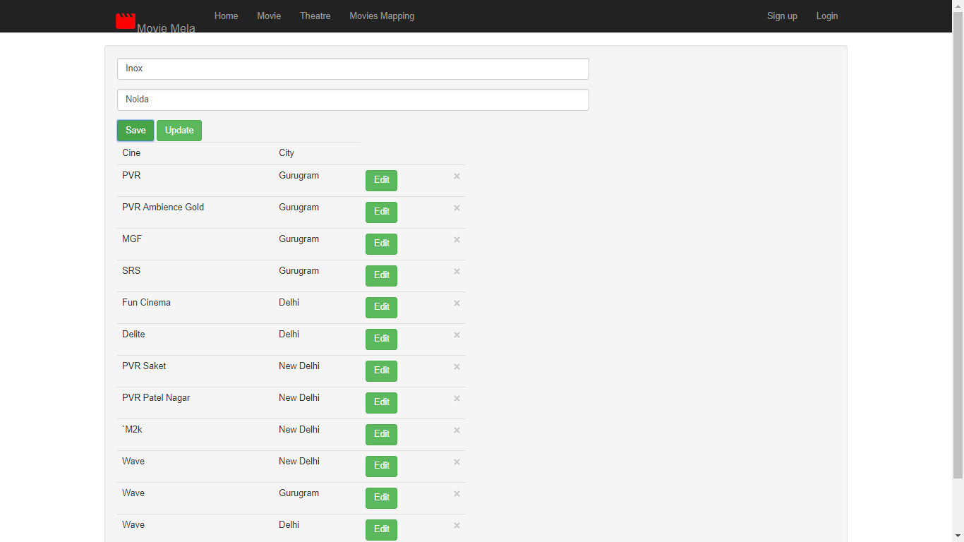

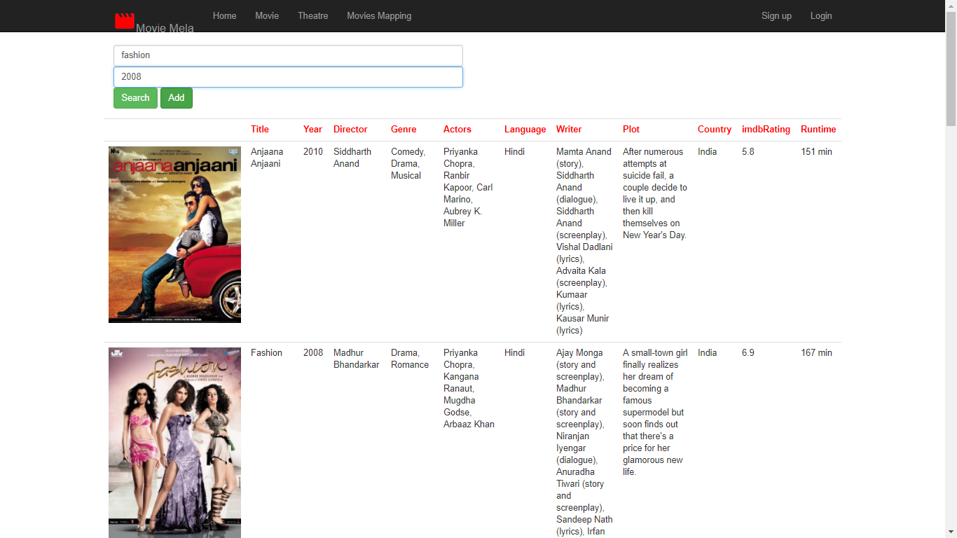

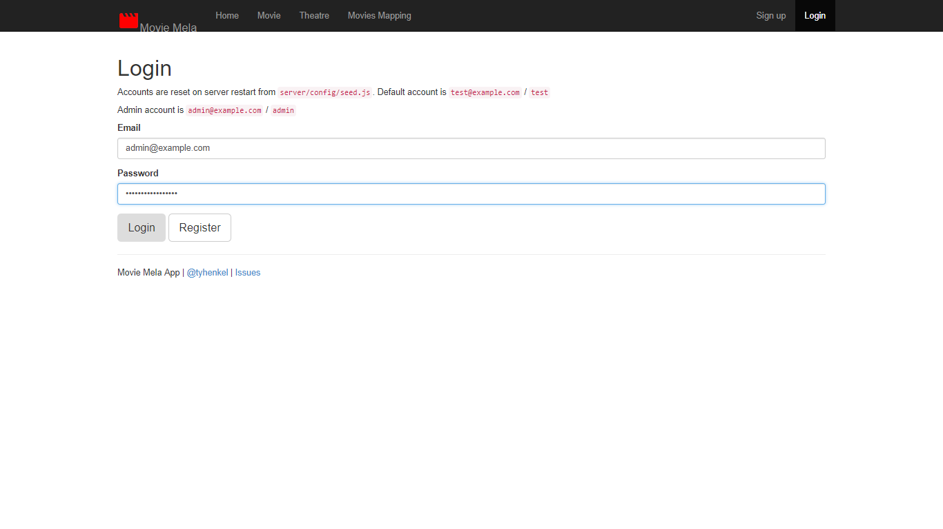

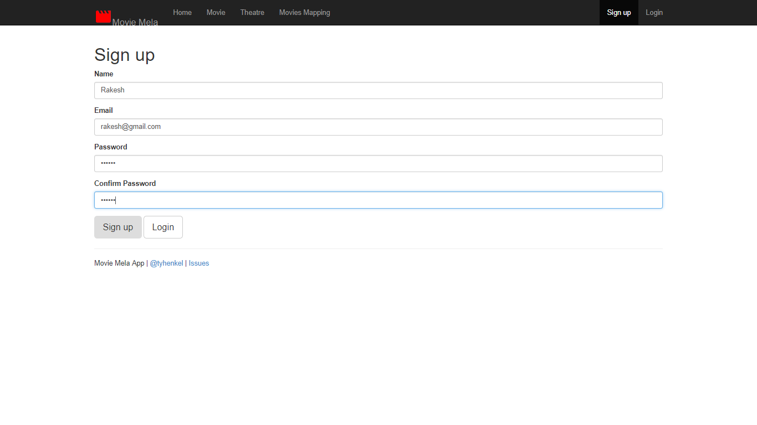

**8. CONCLUSION**

The project was designed in such a way that future modifications can be done easily. The following conclusions can be deduced from the development of the project.

* Automation of the entire system improves the efficiency.
* We can provides the communication between Customer and Cinema Hall.
* Can also create Registration for Customer so that Cinema Hall can contact them about exiting offers.
* Can also make Customer to Post their View on Website.
* The System has adequate scope for modification in future if it is necessary. It is the best way to improve selling Tickets with less efforts.
* This is the best way for customer as well as Cinema Halls to interact with each other without much efforts.

**9. Bibliography and References:-**

**Bibliography**

1.Complete Reference for java by Simon Robinson

2.Headfirst JSP & Servlet

3.Struts2 in Action

4.Learn programming in java by  Lakhanpal Publishers

**References:-**

[**www.w3schools.com**](http://var/www/apps/conversion/tmp/scratch_2/www.w3schools.com)

[**www.fullstack.com**](http://www.fullstack.com)

[**www.html.com**](http://www.html.com)

**www.odbc.com**